

American International University-Bangladesh (AIUB)  
**Department of Computer Science  
Faculty of Science &Technology (FST)  
Fall 20_21**

**Section: J  
Group No: 01**

**MODERN HOUSING MANAGEMENT SYSTEM**

A software Engineering project submitted

By

| Serial No. | Student Name | Student ID |
| --- | --- | --- |
| **21** | **MD. NAIMUL HOSSAIN** | **19-39513-1** |
| **22** | **CHOWDHURY, ANKETA** | **19-39514-1** |
| **25** | **NUR-A-MARZAN DIPRO** | **19-39529-1** |
| **30** | **SAHA, ARNAB** | **19-39836-1** |

The project will be Evaluated for the following Course Outcomes

| Requirements Analysis (functional, quality, and project requirements) [5Marks] | **Total Marks** |
| --- | --- |
| System Design (UML, UI/UX design) [5Marks] |  |
| Test and Project Management Planning [5Marks] |
| Submission, Completeness, Spelling, Grammar and Organization [5Marks] |

Submission Date:19.12.2020

# PRODUCT AND PROJECT DESCRIPTION

## System Features

**Functional Requirements**

**1. Software Login**

**1.1** Already described in exercise-3 example.

**2. Background Color**

**2.1** System by default prefer black ground color to user.

**2.2** System allow user to choose their preferred color.

**2.3** After choosing the color, user can also change it.

**2.4** Users do not need to setup every-time background color. It will automatically saved by system.

**Priority level:**Low.

**Precondition:**Users need to login into the account first.

**Cross-references:** 1.1, 1.2, 1.3

**3. Language**

**3.1** System will automatically prefer the English language to user.

**3.2** System allow user to choose their preferred language.

**3.3** After choosing the language, user can also change it.

**3.4** Users do not need to setup every-time language. It will automatically saved by system.

**Priority level:**Low.

**Precondition:**Users need to login into the account first.

**Cross-references:** 1.1, 1.2, 1.3

**4. Search**

**4.1** User can search anything what he/she wants from writing in search bar.

**4.2** User can see some filtering options from the search bar.

**4.3** Users can see mostly search in last month by the search tab.

**4.4**User can search by selecting some specific requirements.

**4.5** Users can see trending plot and flat ad results by the search tab.

**Priority level:** Medium.

**Precondition:** Users need to login into the account first.

**Cross-references:** 5.1, 5.2, 5.3, 5.4.

**5. Advertisement**

**5.1** Users like plot owner if he wants to rent or sell his plot he can advertise here.

**5.2** Users like land owner if he wants to rent or sell his land he can advertise here.

**5.3** Users like different banking companies can advertise here about their facilities of land and housing loan.

**5.4** Users like various financial aid agencies can advertise here about land and housing loans and also the benefits of these loans.

**Priority level:** High.

**Precondition:** User must have a valid ID and password

**Cross-references:** 4.2, 4.4.

**6. Money Transition**

**6.1** Users who want to advertise here can advertise for a certain amount of money.

**6.2** If users want, they can pay for the advertisement through online banking.

**6.3** If users want, they can pay for the advertisement through bKash, Nagad and Rocket.

**6.4** Users who purchase or rent land and houses must pay us a certain amount of money through online and mobile banking.

**Priority level:** High.

**Precondition:** User must have a valid ID and password

**Cross-references:** 5.1, 5.2, 5.3, 5.4.

**7. Monthly Selling and Renting Report**

**7.1** Every users’ can able to see this report.

**7.2** Users can get a clear idea of how many land and plot is being bought and sold also rented each month can be found.

**7.3** This report will help users to understand how popular is our software.

**Priority level:** Medium.

**Precondition:** User must have a valid ID and password

**Cross-references:** 5.1, 5.2

**8. Discount Offer**

**8.1** Users can see here whether any banking company has given any loan discount which will be beneficial for them.

**8.2** If a landowner wants to rent or sell his land for less than the pre-determined price, users can see it here.

**8.3** If a plot owner wants to rent or sell his plot for less than the pre-determined price, users can see it here.

**Priority level:** Medium.

**Precondition:** User must have a valid ID and password

**Cross-references:** 5.3, 5.4.

**9. Emergency Contact**

**9.1** If any user wants to buy or rent any land in a short time he can contact with us quickly.

**9.2** If any user wants to buy or rent any plot in a short time he can contact with us quickly.

**9.3** If any user wants to sell or rent any plot and land in a short time he can contact with us quickly.

**Priority level:** High.

**Precondition:** User must have a valid ID and password

**Cross-references:** N/A.

**10. Settings & Privacy**

**10.1** Users can update their name, phone number, email addresses.

**10.2** Users can hide their personal information from other users.

**10.3** Users can manage their location settings.

**10.4** Users can also delete and deactivate their account.

**Priority level:** High.

**Precondition:** User must have a valid ID and password

**Cross-references:** 1.1, 1.2, 1.4

**11.** **Account Security**

**11.1** Users can change their password.

**11.2** Users can use two-factor authentication.

**11.3** Users get alerts about unrecognized logins.

**11.4** Users will be able to see from which devices their account was logged in.

**Priority level:** High.

**Precondition:** User must have a valid ID and password

**Cross-references:** 1.1, 1.2, 1.4

**12. Terms and Conditions**

**12.1** In order to use this software, users must abide by certain terms and conditions that are explained here.

**Priority level:** Low.

**Precondition:** Users need to login into the account first.

**Cross-references:** N/A.

**13.Notifications**

**13.1** If any user is interested in a rental or sale ad, he/she may request that advertiser. The advertiser gets a notification.

**13.2** If an advertiser receives a request from a user about his ad and if he accepts it, that user will receive a notification.

**13.3** As developer we will receive notifications when any user tries to contact with us after they face any problems or technical errors.

**Priority level:** Medium.

**Precondition:** User must have a valid ID and password

**Cross-references:** N/A.

**14.Update**

**14.1** User phone regularly gets updates in the background.

**14.2** The Exposure Notifications System was introduced in an update to Google Play Service.

**14.3** The system is turned off by default. This technology only works if user decides to opt-in.

**14.4** If the user changes their mind, they can turn it off at any time.

**Priority level:** Medium.

**Precondition:** User must have a valid ID and password

**Cross-references:** N/A.

**15. Rating**

**15.1** Users will first-rate our software based on how they like our software.

**15.2** Here every user will be able to rate every user.

**15.3** Users can rate them based on the quality of service of banking and financial service providers.

**Priority level:** Low.

**Precondition:** Users need to login into the account first.

**Cross-references:** N/A.

**16. FAQ**

**16.1** There are answers to some common questions about what users should do if they encounter a technical problem.

**16.2** Here are answers to some common questions about how to use this software.

**Priority level:** Low.

**Precondition:** Users need to login into the account first.

**Cross-references:** N/A.

**17. Report**

**17.1** If a user is cheated by another user, they can report it here.

**17.2** Users can report here any unpleasant incidents that already happened to them.

**Priority level:** Low.

**Precondition:** Users need to login into the account first.

**Cross-references:** N/A.

**18.Feedback**

**18.1** Users can select a feedback tab in which a page with a comment box shows up.

**18.2** Users can select some issues that we will give, and there will be other options that the user can define.

**18.3** Users can see some feedback of others their he/she can search for his problem.

**18.4** Users can send Photos with his/her issue so that he/she can give his/her explanation as he/she wants.

**18.5** Users can remove, edit, or update their feedback after submitting it by applying it to the developers.

**Priority level:** Low.

**Precondition:** Users need to login into the account first.

**Cross-references:** N/A.

## System Quality Attributes

Our designed application is internet and mainframe base application. That’s why we have to ensure some quality attributes.

**Availability:** Our system will available almost all the time. Every user will be able to take any facilities from this system. The system will be at least 95.5 percent available on weekdays between 5:00 AM to midnight local time, and at least 98.4 percent available on weekdays between 3:00 PM to 8:00 PM local time.

**Integrity:** Users' personal information is stored securely on our system. Only authorized users can access this system. Our system blocked all unauthorized access by itself.

**Maintainability:** We try our best to maintain our system. If there is any problem with the system we try to fix it as soon as possible so that the users do not face any interruptions while using this system.

**Usability:** Our application is very easy to use. We make our user interface reliable as if users' can easily find all options that they want. We continuously work on this to make our application more user-friendly.

**Portability:** An authorized user can log in to this system from anywhere via any device by using the internet.

**Reliability:** The system is totally reliable as it will be connected with the government in the future.

**Reusability:** Any component of our application can be used later in different software which will be able to reduce the work cost of the next project.

**Flexibility:** Our application is very flexible. Later, if we want to add any new feature to our application. we can easily do it and our users can witness a new experience.

## Project Requirements

In this part we give a description of system property, attribute and how the system of project Modern Housing Management System should behave. That’s why project conditions play a significant role in the development and implementation of the project. They may be a constraint on the development process of the system. Some project requirements are given below by analyzing all the data regarding the project. They are used to develop new products and improve existing ones. This requirement will collect from the stakeholders, such as business units, users, and operations and developer experts. The following are illustrative examples of project requirements.

**User:** The software is user-friendly, so requirements contributed by users are the lead users.

**Features:** The software shall have a securely mounted balance between users and developers. Features of the system should be updated with the time. Developer will ensure the newest features and keep up to date the system regularly.

**System Analyst**: The system will be updated every hour with recent and authentic information to deliver to the users.

**Business requirement:** Accurate monthly sales forecast required for the project. For that, a new sales system is needed to be developed. It will only authorize for specifics so that data will be secured.

**Resources:** Resources are strongly connected to the project cost. The amount of money that’s available for achieving the desired outcome will restrict the use and acquisition of resources, which creates a separate constraint. If resource is essential to the project, we’ll have to sacrifice making the deadline, because no reasonable amount of money could reduce the delivery time. Resources of project should be high utilized

**Performance:** The software shall have a maximum user efficiency of at least 90% so that everyone can use the software without issue. Maintaining performance in software development is tough, but important to satisfy users. The software is user-friendly, so requirements contributed by users are the lead users.

**Service requirement:** Services for the user and others will be available at least 99% of the time. Any bugs or malware issues can be fixed, and thus no one will face any interruption. If any user faces problem with their product or order, a team always there to response. They will solve the problem of the user. If any user comes with a wrong product, legal action will be taken against that user.

**Risk:** The software server might get crashed, or the website might get broken. Due to heavy users visit the website at a time, and the chance is 0.1-.05%. Managing risks is an important task for project managers. When you estimate probability, a risk will have a certain impact on your project. For instance, we can decide to avoid the risk and insist on the review step. But this decision would affect our timeline and our related costs, since the client would review each of your designs, and a project manager needs to oversee this process. The software server might get crashed, or the website might get broken.

**Quality:** The software will provide every user with a premium quality security and user interface since the software maintains resourceful data and security quality.

**Budget:** This software is a start-up, so it needs funding from the stakeholders. The percentage will be 60% for the stakeholders and 40% for the developers in the beginning.

# SYSTEM DESIGN SPECIFICATION

## System Design:

**2.2.1 Use-Case Diagram**:

* **Use Case Diagram** shows the main actors of our system and their role in our management system. Here customer is the pivotal point where he or she sign up or log in by providing their personal information and looks for information about what they are looking for. Then they pay through their preferred method after finding their seeking object via information. Employees accept or deny their verification request and purchase request also updates user information. Manager often tests integrity and updates software also performs security check often. Accountants manages customer accounts and contacts bank for loan and transaction works also create bills. Technical support takes query from customer and solves software issues also and they frequently contact with the clients. Finally, advertisers advertise about new plot or flat that’s available and looks for new marketplace.
* **Actor**:

**Customer**: finds information, provides personal information, contacts client, do payment

**Manager**: manages overall company, controls security and applications integrity also update system as its required.

**Employee**: accepts or denies customer for doing transaction, verifies customer, updates user information.

**Accountant**: creates bills, contacts with the banks, manages user accounts

**Advertisers**: advertises about new plot or flat and rentals, also finds new marketplace.

**Technical** **Support**: contacts clients, takes query from clients, solves user’s software issues.

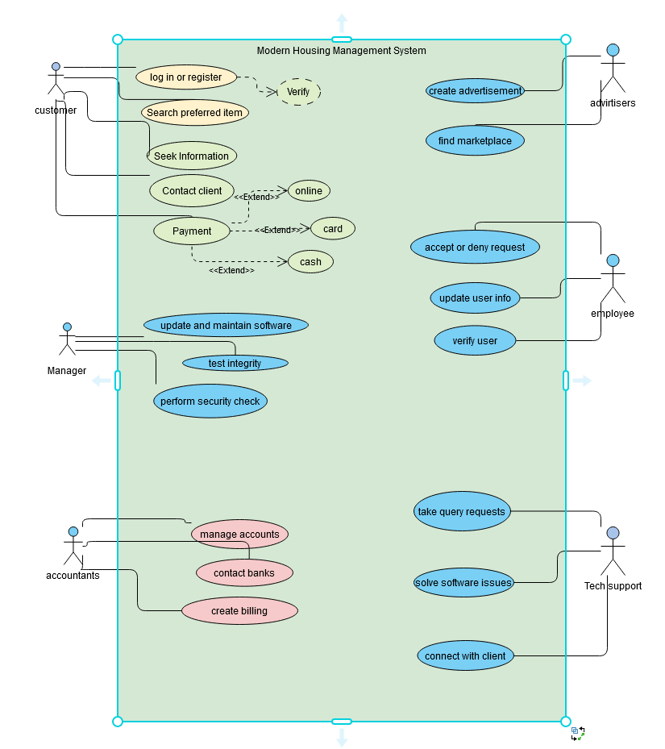



**2.2.2 Activity Diagram:**

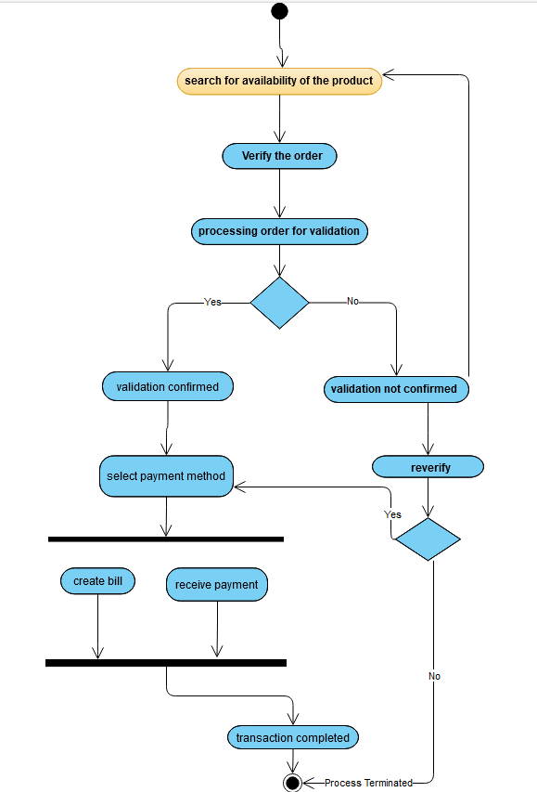



**Activity Diagram**

This is the Activity Diagram of our Modern Housing Management System. In this diagram, we showed the activity from a searching of a product to the total completion of transaction. Initially, the customer will search for their desire item and then they will verify their order. The order is then validated and processed. If its confirmed, then the customer is asked to select their choosing of payment method. Then a bill is created and also the system receives payment. Upon completing, the transaction is completed. If the validation is not confirmed, it goes to reverify or the product is searched again. If reverified, the customer is given the permission to select payment method and complete transaction. If not reverified, the process is terminated automatically.

**2.2.3** **Class** **Diagram**: Showing the main classes of the given system.

* **Class**: Manager, Employee, Accountant, Technical Support, Customer, Advertiser, Payment, Flat||Plot
* **Attribute**:

Manager: m_id, m_name, m_salary, m_phoneNumber, e_id(fk)

Employee: e_id**,** e_name, e_salary, e_address, e_phnumber, m_id(fk)

Accountant: a_id, a_name, a_salary, a_phnumber, m_id(fk

Customer: c_id, c_name, c_adress, c_phnumber, c_occupation, c_age, c_nationality,

t_id(fk), a_id(fk), p_id(fk)

Technical Support: t_id**,** t_name, t_salary, t_phnumber, c_id(fk)

Advertiser: adv_id**,** adv_name, adv_salary, adv_phnumber, adv_region, fp_id(fk)

Payment: p_id, p_name, p_amount, p_date, c_id(fk), m_id(fk)

Flat||Plot: fp_id, fp_name, fp_price, fp_phnumber, fp_region, adv_id(fk)

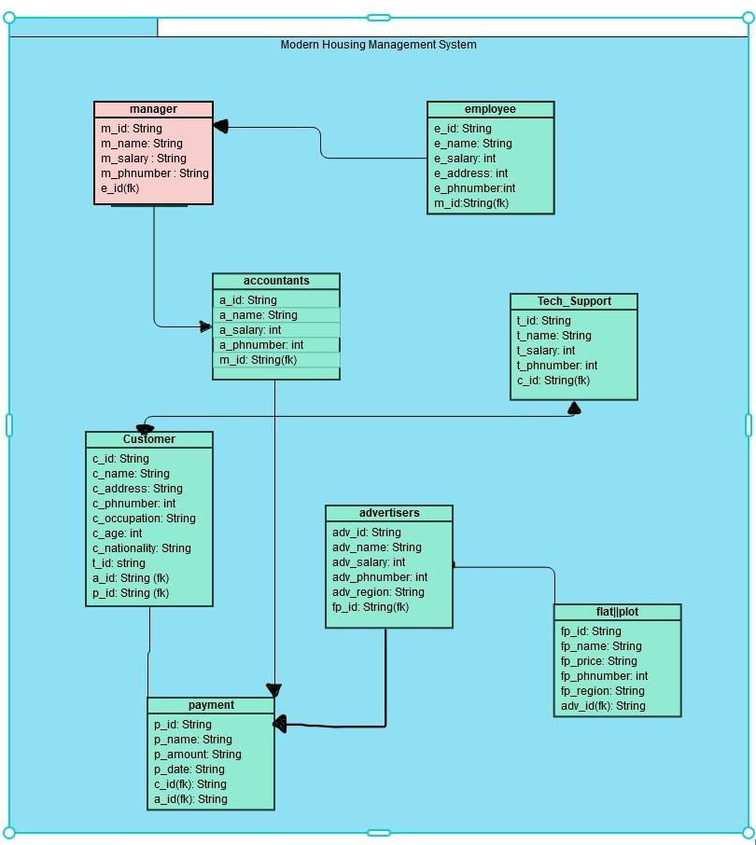



**2.2.4 ER Diagram:**

In this Entity-Relationship diagram the model is fully represented with entities and attributes with the relation between them. Also, we mentioned the primary key (underlined) and foreign key(fk) also.

* **Entitles and Attributes:**

**Manager**: m_id, m_name, m_salary, m_phoneNumber, e_id(fk)

**Employee**: e_id**,** e_name, e_salary, e_address, e_phnumber, m_id(fk)

**Accountant**: a_id, a_name, a_salary, a_phnumber, m_id(fk

**Customer**: c_id, c_name, c_address, c_phnumber, c_occupation, c_age, c_nationality,

t_id(fk), a_id(fk), p_id(fk)

**Technical** **Support**: t_id**,** t_name, t_salary, t_phnumber, c_id(fk)

**Advertiser**: adv_id**,** adv_name, adv_salary, adv_phnumber, adv_region, fp_id(fk)

**Payment**: p_id, p_name, p_amount, p_date, c_id(fk), m_id(fk)

**Flat||Plot**: fp_id, fp_name, fp_price, fp_phnumber, fp_region, adv_id(fk)

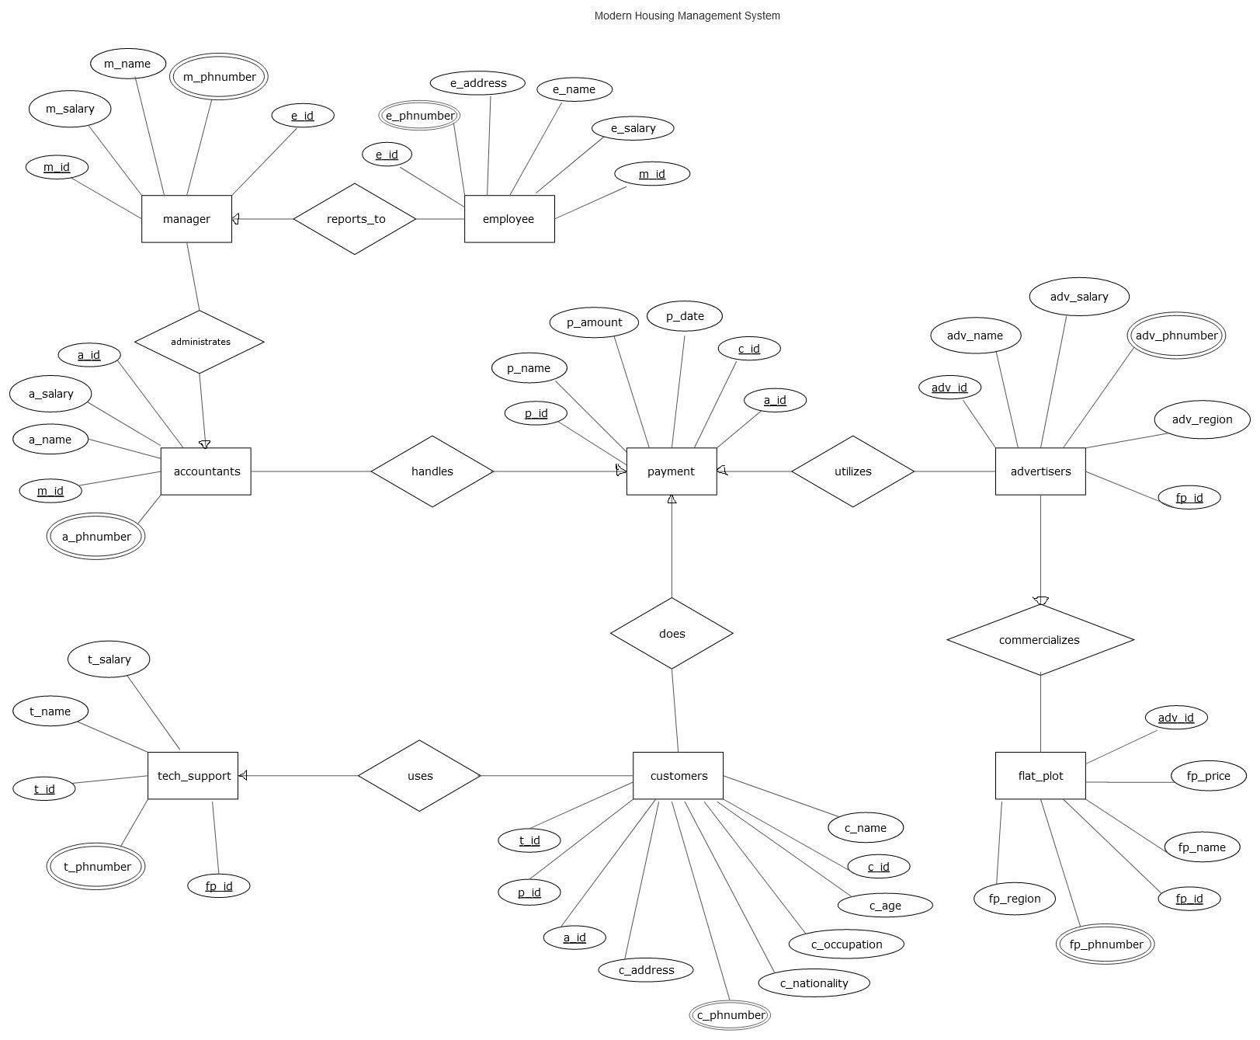



## UI/UX design for the Mobile Application:

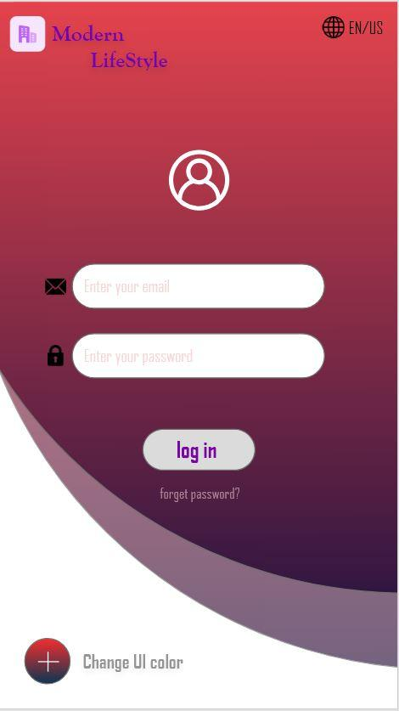

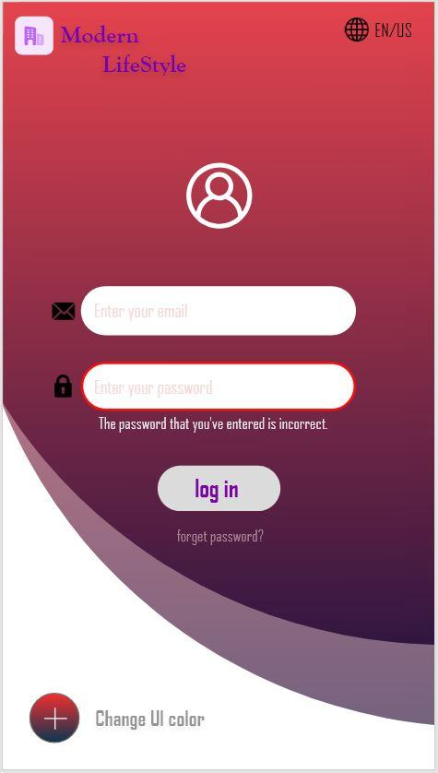

**Fig 1: Log in page Fig 2: Incorrect Password page**

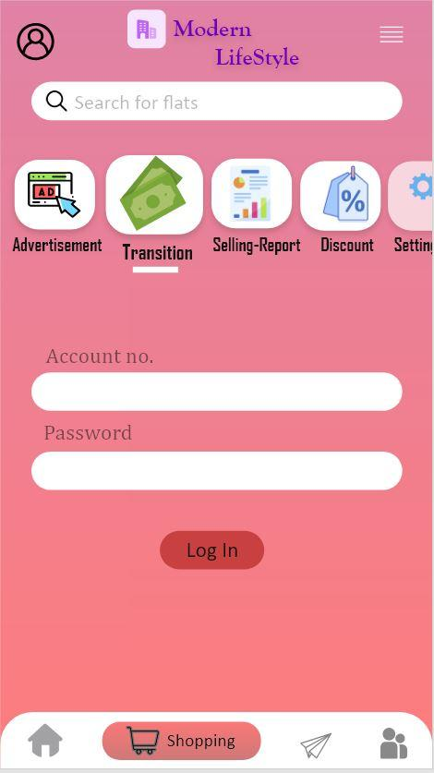  
 **Fig 3: Advertisement page** **Fig 4: Transition page**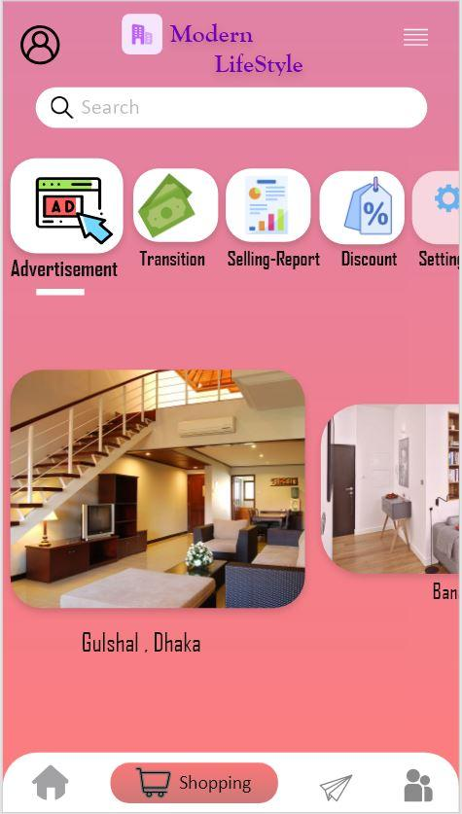

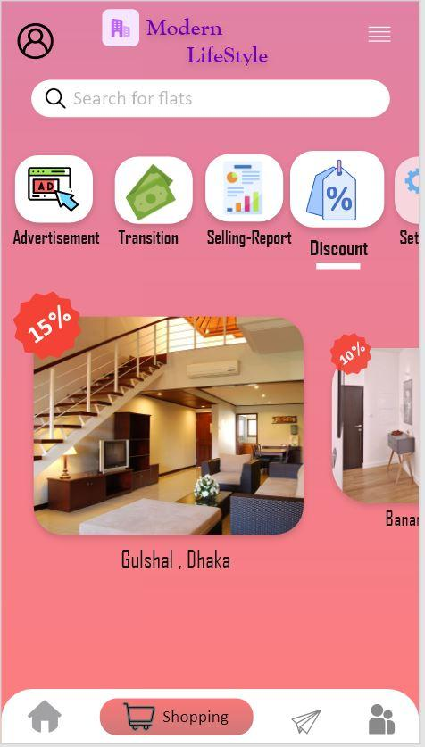  
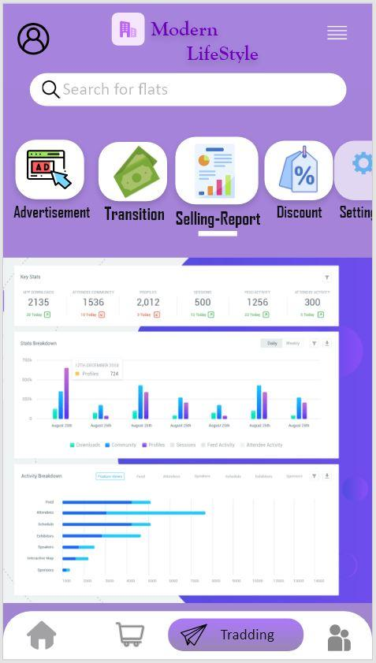

**Fig 5: Selling-Report page Fig 6: Discount page**

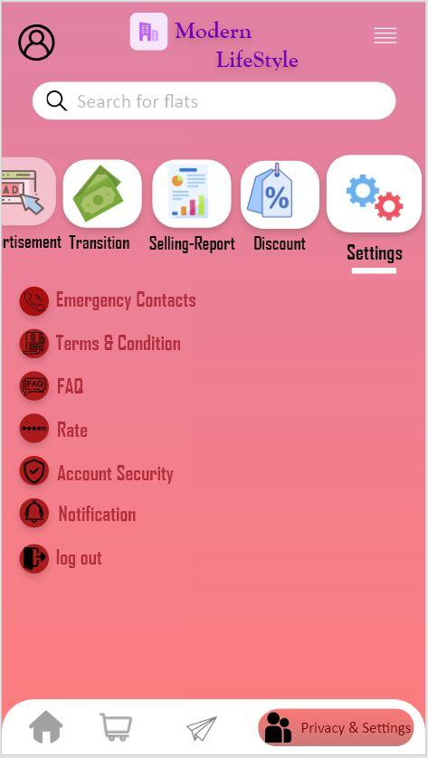

**Fig 7: Settings page**

# SYSTEM TEST PLAN

| Project Name: Modern Housing Management System | | | Test Designed by: Dipro Haque | |
| --- | --- | --- | --- | --- |
| Test Case ID: FR_2 | | | Test Designed date:16/12/2020 | |
| Test Priority (Low, Medium, High): Low | | | Test Executed by: Arnab Saha | |
| Module Name: Background Color Session | | | Test Execution date: 16/12/2020 | |
| Test Title: Verify background color changing with user preference | | | | |
| Description: Test Application background color change page | | | | |
| Precondition (If any): User need to login into the account first. | | | | |
| Test Steps | Test Data | Expected Results | Actual Results | Status (Pass/Fail) |
| 1. Go to the Application.  2. Enter User id and password to login into the user profile.  3.Go to the User account select the background color icon.  4. Select a preferred color. | Language Type:  1. Black  2.White  3.Navy Blue  4. Purple  5. Mint Green | Account holder Should get his/her selected color. | As expected | Pass |
| Post Condition: Users have to download the application. And the device must support the application. | | | | |

| Project Name: Modern Housing Management System | | | Test Designed by: Dipro Haque | |
| --- | --- | --- | --- | --- |
| Test Case ID: FR_3 | | | Test Designed date:16/12/2020 | |
| Test Priority (Low, Medium, High): Low | | | Test Executed by: Arnab Saha | |
| Module Name: Language Session | | | Test Execution date: 16/12/2020 | |
| Test Title: Verify language changing with user preference | | | | |
| Description: Test Application language change page | | | | |
| Precondition (If any): User need to login into the account first. | | | | |
| Test Steps | Test Data | Expected Results | Actual Results | Status (Pass/Fail) |
| 1. Go to the Application.  2. Enter User id and password to login into the user profile.  3.Go to the User account select the language icon.  4. Select a preferred language. | Language Type:  1.Bangla  2.English(USA)  3.English(UK)  4. French  5. Spanish | Account holder Should get his/her selected language. | As expected | Pass |
| Post Condition: Users have to download the application. And the device must support the application and also the language. | | | | |

| Project Name: Modern Housing Management System | | | | Test Designed by: Md. Naimul Hossain | |
| --- | --- | --- | --- | --- | --- |
| Test Case ID: FR_4 | | | | Test Designed date: 16/12/2020 | |
| Test Priority (Low, Medium, High): Medium | | | | Test Executed by: Anketa Chowdhury | |
| Module Name: Search Session | | | | Test Execution date:16/12/2020 | |
| Test Title: Verify the Search Bar with searching any user account or ads | | | | | |
| Description: Test Application search page. | | | | | |
| Precondition (If any): User need to login into the account first. | | | | | |
| Test Steps | Test Data | Expected Results | Actual Results | | Status (Pass/Fail) |
| 1.Go to Application login page.  2.Enter User ID.  3.Enter User Password.  4. Go to Search bar  5.Type anything user want to search | To find desired  user account, Offer and Ads | User should successfully found which they want | As expected | | Pass |
| Post Condition: Users will only be able to find those things that are included in this system by searching | | | | | |

| Project Name: Modern Housing Management System | | | | Test Designed by: Md. Naimul Hossain | |
| --- | --- | --- | --- | --- | --- |
| Test Case ID: FR_5 | | | | Test Designed date: 16/12/2020 | |
| Test Priority (Low, Medium, High): High | | | | Test Executed by: Anketa Chowdhury | |
| Module Name: Advertisement Session | | | | Test Execution date:16/12/2020 | |
| Test Title: Verify the Advertisement section with publishing an advertising | | | | | |
| Description: Test Application advertisement page. | | | | | |
| Precondition (If any): User must have a valid ID and password | | | | | |
| Test Steps | Test Data | Expected Results | Actual Results | | Status (Pass/Fail) |
| 1.Go to Application login page.  2.Enter User ID.  3.Enter User Password.  4. Go to advertisement section  5. Upload any picture or video for advertisement purpose | Pictures and videos | User should successfully upload picture or video for ads | As expected | | Pass |
| Post Condition: Users can only upload that kind of picture and videos which is related to our application content | | | | | |

| Project Name: Modern Housing Management System | | | | Test Designed by: Arnab Saha | |
| --- | --- | --- | --- | --- | --- |
| Test Case ID: FR_6 | | | | Test Designed date: 16/12/2020 | |
| Test Priority (Low, Medium, High): High | | | | Test Executed by: Anketa Chowdhury | |
| Module Name: Money Transition Session | | | | Test Execution date:16/12/2020 | |
| Test Title: Verify the Money Transition section with transferring some money | | | | | |
| Description: Test Application Money transition page | | | | | |
| Precondition (If any): User must have a valid ID and password | | | | | |
| Test Steps | Test Data | Expected Results | Actual Results | | Status (Pass/Fail) |
| 1.Go to Application login page.  2.Enter User ID.  3.Enter User Password.  4. Go to money transition section  5. Transfer some money using online banking, bKash or nagad | Money transfer | User should successfully transfer money by online or mobile banking | As expected | | Pass |
| Post Condition: Users can only transfer money to us. Any other money transition is not allowed. | | | | | |

| Project Name: Modern Housing Management System | | | | Test Designed by: Dipro Haque | |
| --- | --- | --- | --- | --- | --- |
| Test Case ID: FR_7 | | | | Test Designed date: 16/12/2020 | |
| Test Priority (Low, Medium, High): Medium | | | | Test Executed by: Anketa Chowdhury | |
| Module Name: Monthly Selling and Renting Report Session | | | | Test Execution date:16/12/2020 | |
| Test Title: Verify the Monthly Selling and Renting Report section by finding all report of last month | | | | | |
| Description: Test Application Monthly Selling and Renting Report page | | | | | |
| Precondition (If any): User must have a valid ID and password | | | | | |
| Test Steps | Test Data | Expected Results | Actual Results | | Status (Pass/Fail) |
| 1.Go to Application login page.  2.Enter User ID.  3.Enter User Password.  4. Go to monthly selling and renting report section  5. Check some report which was done in last month | Monthly plot-flat selling and renting report history | User should find all the record of last month | As expected | | Pass |
| Post Condition: Users can able to see all the previous months report | | | | | |

| Project Name: Modern Housing Management System | | | | Test Designed by: Dipro Haque | |
| --- | --- | --- | --- | --- | --- |
| Test Case ID: FR_8 | | | | Test Designed date: 16/12/2020 | |
| Test Priority (Low, Medium, High): Medium | | | | Test Executed by: Anketa Chowdhury | |
| Module Name: Discount Offer Session | | | | Test Execution date:16/12/2020 | |
| Test Title: Verify the Discount offer section by giving some discount on existing ads | | | | | |
| Description: Test Application Discount Offer page | | | | | |
| Precondition (If any): User must have a valid ID and password | | | | | |
| Test Steps | Test Data | Expected Results | Actual Results | | Status (Pass/Fail) |
| 1.Go to Application login page.  2.Enter User ID.  3.Enter User Password.  4. Go to discount offer section  5. Can see the available discounted ads | Discounted ads | User should find all discounted ads | As expected | | Pass |
| Post Condition: Users can only able to see which ads discount offer is running. | | | | | |

| Project Name: Modern Housing Management System | | | | Test Designed by: Dipro Haque | |
| --- | --- | --- | --- | --- | --- |
| Test Case ID: FR_9 | | | | Test Designed date: 16/12/2020 | |
| Test Priority (Low, Medium, High): High | | | | Test Executed by: Anketa Chowdhury | |
| Module Name: Emergency ContactSession | | | | Test Execution date:16/12/2020 | |
| Test Title: Verify the Emergency Contact section by contacting with us | | | | | |
| Description: Test Application Emergency Contact page | | | | | |
| Precondition (If any): User must have a valid ID and password | | | | | |
| Test Steps | Test Data | Expected Results | Actual Results | | Status (Pass/Fail) |
| 1.Go to Application login page.  2.Enter User ID.  3.Enter User Password.  4. Go to emergency contact section  5. Make a call to us for any emergency situation | Make a call to us | User should successfully contact us by using this feature | As expected | | Pass |
| Post Condition: Users can only able to contact us for emergency rent and sell plot or flat | | | | | |

| Project Name: Modern Housing Management System | | | | Test Designed by: Md. Naimul Hossain | |
| --- | --- | --- | --- | --- | --- |
| Test Case ID: FR_10 | | | | Test Designed date: 16/12/2020 | |
| Test Priority (Low, Medium, High): High | | | | Test Executed by: Anketa Chowdhury | |
| Module Name: Settings & Privacy Session | | | | Test Execution date:16/12/2020 | |
| Test Title: Verify the Settings & Privacy section by changing some personal information | | | | | |
| Description: Test Application Settings & Privacy page | | | | | |
| Precondition (If any): User must have a valid ID and password | | | | | |
| Test Steps | Test Data | Expected Results | Actual Results | | Status (Pass/Fail) |
| 1.Go to Application login page.  2.Enter User ID.  3.Enter User Password.  4. Go to settings & privacy section  5. Can change the current setting and privacy status | Personal information change | User should successfully change personal information | As expected | | Pass |
| Post Condition: Users can not able to frequently change their personal information. After passing 50 days they can change their personal information again | | | | | |

| Project Name: Modern Housing Management System | | | | Test Designed by: Md. Naimul Hossain | |
| --- | --- | --- | --- | --- | --- |
| Test Case ID: FR_11 | | | | Test Designed date: 16/12/2020 | |
| Test Priority (Low, Medium, High): High | | | | Test Executed by: Arnab Saha | |
| Module Name: Account Security Session | | | | Test Execution date:17/12/2020 | |
| Test Title: Verify the Account Security section trying to access a valid account as an unauthorized user | | | | | |
| Description: Test Application Account Security page | | | | | |
| Precondition (If any): User must have a valid ID and password | | | | | |
| Test Steps | Test Data | Expected Results | Actual Results | | Status (Pass/Fail) |
| 1.Go to Application login page.  2.Enter User ID.  3.Enter User Password.  4. Go to account security section  5. Can see account security system | User account,  Unauthorized user | Security system should automatically block unauthorized access into the user account | As expected | | Pass |
| Post Condition: Users have to enable their two-factor authentication and unauthorized login alerts | | | | | |

| Project Name: Modern Housing Management System | | | | Test Designed by: Md. Naimul Hossain | |
| --- | --- | --- | --- | --- | --- |
| Test Case ID: FR_13 | | | | Test Designed date: 16/12/2020 | |
| Test Priority (Low, Medium, High): Medium | | | | Test Executed by: Arnab Saha | |
| Module Name: Notification Session | | | | Test Execution date:17/12/2020 | |
| Test Title: Verify the Notification section by getting any notification alert | | | | | |
| Description: Test Application Notification page | | | | | |
| Precondition (If any): User must have a valid ID and password | | | | | |
| Test Steps | Test Data | Expected Results | Actual Results | | Status (Pass/Fail) |
| 1.Go to Application login page.  2.Enter User ID.  3.Enter User Password.  4. Go to notification section  5. Can see account’s every notification | All kinds of account notification | User should successfully get notification alerts | As expected | | Pass |
| Post Condition: Users will receive notifications for each of his activities immediately | | | | | |

| Project Name: Modern Housing Management System | | | | Test Designed by: Md. Naimul Hossain | |
| --- | --- | --- | --- | --- | --- |
| Test Case ID: FR_14 | | | | Test Designed date: 17/12/2020 | |
| Test Priority (Low, Medium, High): Medium | | | | Test Executed by: Dipro Haque | |
| Module Name: Update Session | | | | Test Execution date:18/12/2020 | |
| Test Title: Verify the Update section with validating google play account | | | | | |
| Description: Test Application Update page | | | | | |
| Precondition (If any): User must have a valid ID and password | | | | | |
| Test Steps | Test Data | Expected Results | Actual Results | | Status (Pass/Fail) |
| 1.Go to Application login page.  2.Enter User ID.  3.Enter User Password.  4. Go to play store  5. Now, switch to upgrade version of this application | Download update version of this app | User should successfully updated their application | As expected | | Pass |
| Post Condition: If users want to get a notification from the app to ask them to update the current version application. Then user enable the update alert option and get a notification when a new version is released | | | | | |

| Project Name: Modern Housing Management System | | | | Test Designed by: Md. Naimul Hossain | |
| --- | --- | --- | --- | --- | --- |
| Test Case ID: FR_18 | | | | Test Designed date: 16/12/2020 | |
| Test Priority (Low, Medium, High): Low | | | | Test Executed by: Arnab Saha | |
| Module Name: Feedback Session | | | | Test Execution date:17/12/2020 | |
| Test Title: Verify the Feedback section when user giving their opinion about this app on the comment box | | | | | |
| Description: Test Application Feedback page | | | | | |
| Precondition (If any): Users need to login into the account first | | | | | |
| Test Steps | Test Data | Expected Results | Actual Results | | Status (Pass/Fail) |
| 1.Go to Application login page.  2.Enter User ID.  3.Enter User Password.  4. Go to feedback section  5. Can write the user experience about this app | Many comments about the user experience on this app | User should successfully give their opinion on the feedback comment box | As expected | | Pass |
| Post Condition: User can provide the screenshot on which section we need to improve | | | | | |